Harassment Charge Dismissed Against Texas Attorney
For Telling Client She Was “Full of Crap.”

(Nacogdoches Texas, May 5th, 2022) The Nacogdoches County Attorney has dismissed a criminal charge against a local attorney who responded to a delinquent client’s email that she was “full of crap” over her protestations regarding an unpaid legal bill.

In December of 2020, Attorney Paul Anderson was charged with a misdemeanor B for responding to an email from a client that the client “ was full of crap” when she refused to pay a past due legal bill for her divorce.

Anderson’s arrest drew media attention and an article was published in Texas Lawyer magazine. See link below. Anderson alleges that the charge was motivated to intimidate him into not filing civil rights lawsuits and claims related to corruption in the District Attorney’s Office and Nacogdoches County law enforcement abuses. Five civil rights lawsuits and several more claims have been filed against Nacogdoches County for abuse since Anderson’s arrest.

Defendant Lori Tanton had been sued in civil court for unpaid legal services by Paul Anderson when she filed a complaint with the Nacogdoches County Sheriff’s Office stating that, “On 12-03-2020 at approximately 1320. [sic] Deputies responded to the address of 3073 County Road 898 in reference to a harassment call. Lori informed deputies that Paul had contacted her via email. Lori forwarded a copy of the email to the Deputies. The email stated the following: “Hello Lori, just wanted to remind you to read your email below and you will realize how full of crap you are.”

On December 4th, 2020 Nacogdoches County Sheriff Deputies unsuccessfully attempted to arrest Paul Anderson at his office a few minutes after the arrest warrant was issued.

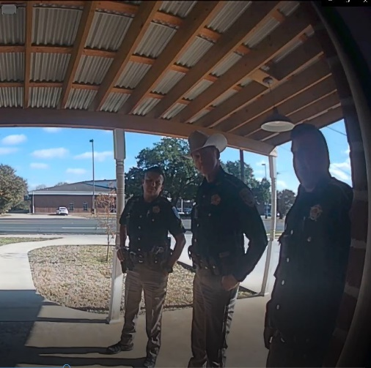

Anderson voluntarily turned himself in to the Nacogdoches County Jail and paid bail but was held in the Nacogdoches County Jail for five hours without explanation or justification before being released.

The charges against Anderson were dropped 16 months after his arrest. Anderson’s dismissal can be found here. Anderson says he is preparing a lawsuit against Nacogdoches County for malicious criminal prosecution.

Paul Anderson is the principal attorney in a Nacogdoches, Texas civil rights law firm specializing in public corruption, fraud and law enforcement abuse. If you have information about this case, or any matter involving official oppression, malicious prosecution, abuse of process, corruption, or public fraud, submit a consultation request via the firm’s website.

See https://www.law.com/texaslawyer/2020/12/08/a-lawyer-was-charged-with-harassing-his-client-he-claims-it-was-really-for-challenging-a-prosecutor/.

